



INITIAL
ASSESSMENT
REPORT

DATE: 24th May 2024
Human Resources –
HR Operations,
Talent Acquisition (Area Manager & Above + HO),
(Branch Manager & Below)
Training & Development

VERSION: 1.2

Document History
Document version | Remarks | Submitted  By | Submission  Date | Approved BY | Approval  Date
1.0 | First Draft | k&S Digiprotect | 10th May 2024
1.1 | Second Draft | k&S Digiprotect | 22nd May 2024
1.2 | Final Draft | K&S Digiprotect | 24th May 2024

Table of Contents
Introduction 4
Objectives 4
General Information 5
SPOC Information 5
Department Hierarchy* 6
Key Processes 7
Data Flow Diagram (DFD) 10
Data Mapping and Inventory 11
Recommendations 13
Action Plan 13
Requirements 13
Conclusion 13
Appendices 14
Appendix A 14

Introduction
The HR Department at India Shelter Finance Corporation Limited (ISFC) facilitates the organization's human capital strategy. Talent Acquisition handles the recruitment process from sourcing candidates to conducting interviews and facilitating the onboarding process, HR ensures the organization attracts and retains top talent vital for driving ISFC's growth and success.
ISFC's HR Ops Department oversees a spectrum of functions essential for employee well-being and organizational efficiency. This includes managing payroll, administering benefits, and maintaining compliance with labour laws and regulatory requirements. Training & Development for employees and external partners is also taken care of by the HR Department. By nurturing a conducive work environment and supporting the diverse needs of its workforce, the HR Department at ISFC contributes significantly to the organization's overall success and sustainability.
This report encapsulates critical insights derived from an extensive interview conducted with the Human Resource Department of India Shelter Finance Corporation Limited (ISFC) for compliance with the Digital Personal Data Protection Act (DPDPA), and implementation of ISO/IEC 27001:2022.
The overarching objectives of this interview were dual fold: first, to gain an understanding of the departmental structure, and second, to delve into the core operational processes of the Administration Department. Additionally, the interview aimed to assess the existing information security practices, focusing on evaluating the readiness for adherence to DPDPA requirements, and ISO/IEC 27001:2022 implementation.
By delving into the details of the department's organizational setup, operational workflows, and data handling procedures, this report endeavours to identify both the strengths and areas of improvement in information security management and DPDPA compliance within the HR department.

Objectives
- Understand the departmental hierarchy and reporting structure
- Learn the existing processes of ISFC’s HR Ops, TA, and Training & Development
- Mapping of existing processes with documented processes
- Offer recommendations to optimize the existing processes

General Information
Organization Name | India Shelter Finance Corporation Limited
Department Name | Human Resources (HR Ops, TA, Training & Development)
Date of the Assessment | HR Ops – 13th March 2024  TA (Area Manager & Above Pan India + Complete HO) – 12th April 2024  TA (Branch Manager & Below), Training & Development – 26th April 2024
Location | 3rd Floor, 6th Floor, India Shelter HQ, Gurugram
Meeting Duration | HR Ops – 1 hour  TA (AM & Above + HQ) – 1 hour  TA (BM & Below), Training & Development – 30 Minutes
Attendees (ISFC) | Sharad Pareek, Madhu Sharma, Sanjay, Amit, Aditya Choubey, Vijayananda Shenoi, Dheeraj Yadav, Bal Mukund, Sunil Kumar Sharma
Attendees (Digiprotect) | Lalit Mohan Joshi, Sushil Menon, Manav Mahajan, Adhita Razdan

SPOC Information
Project SPOC: Dheeraj Yadav
Contact Information:
Email ID: dheeraj.yadav@indiashelter.in

Project Coordinator: Sunil Kumar Sharma
Contact Information:
Email ID: sunil.sharma2@indiashelter.in

Department SPOC:
- HR Ops – Madhu Sharma
- TA (Area Manager & Above Pan India + Complete HO) – Aditya Choubey
- TA (Branch Manager & Below) – Vijayananda Shenoi
- Learning & Development – Vijayananda Shenoi

Contact Information:
Email ID:
- Madhu Sharma: madhu.sharma@indiashelter.in
- Aditya Choubey: aditya.choubey@indiashelter.in
- Vijayananda Shenoi: vijayananda.shenoi@indiashelter.in

Department Hierarchy*

* As informed during the meeting

Key Processes
S. No | Key Activities | Observations and Asks | Remarks
 | Recruitment  Recruitment Process is split into:  - Area Managers and above pan India along with all HQ hiring is done by Aditya  - Business team communicates requirement through mails or on calls  - Candidate Sourcing is done from Job Portals (LinkedIn, Naukri, etc.), through external consultants, and internal references.  - Resume are shared to business teams through emails and if selected, interviews are scheduled on MS Teams.  - 1st Round Interview with L1 Manager, 2nd round with L2 Manager.  - Post selection of candidate, documents are collected. (KYC Documents - Aadhar, Pan Card, DL (for sales profile), Education history, Salary slips, Increment slip, Photographs, etc.)  - Documents are shared with Operations team for CIBIL check.  - Family details, nominee details, geographic data, hometown, blood group, etc are collected after CIBIL check.  - Salary negotiation is done after CIBIL check. Final approval of salary is taken from VP HR and CHRO.  - After approval, all documents are sent to HR Ops team for releasing offer letter.  - Recruitment for Loan Officer (LO), Branch Manager (BM) is done by Vijayananda Shenoi  - Candidate sourcing is mostly done through References, Job portals, and Consultants. | - All Resumes are retained indefinitely.  - All data is stored on Local machines and/or one drive.  - ATS might be enrolled in FY 24-25.  - ISFC to confirm the Order of interviews recorded in Talent Acquisition SOP vs On-Ground.  - ISFC to explain Re-hiring Process.  - ISFC to explain New Role creation/ Hiring Process.  - ISFC to explain about NAPS process, NAPS vendors, ALT app. | - Documents (KYC Documents, other information required for recruitment) are sometimes received via WhatsApp.  - No classification of emails, data, or information is done.  - No data deletion policy available/ enforced.
 | Background Verification (BGV)  - Background Verification (BGV) is done via external vendors, post joining. This process is taken care of by HR Ops team.  - All documents are sent on emails to the BGV vendors. Reports are also received via emails. | NA | - No specific clause for data retention/deletion with Background Verification (BGV) vendors.
 | Onboarding  - HR Ops team releases Offer Letter to selected candidate.  - Joining days are Monday & Thursday only. Joining on any other day needs special approval from CHRO.  - All employees are on-roll.  - Details for ID Card are shared with Admin Team by HR Ops via Email. | NA
 | Insurance  - Employee Insurance is taken care of by HR Ops team.  - There are 4 types of Insurance Policies available for Employees: Individual Mediclaim, Family insurance (parental (add-on)), Accidental, Term. | - ISFC to explain Policy renewal process
 | Budgeting  - Budgeting for Headcount, Payroll Cost, and Non-payroll Cost is done by HR Ops team. | NA
 | Training  - Training and development are done by VP HR.  - External Training given to people working in call centres. Training material is given to them, and a confirmation is taken over email about completion of training.  - Induction program – Parichay is taken by all New Joiners. | - ISFC to confirm other training programs held for employees.  - ISFC to provide details on training calendar.  - ISFC to provide training records.  - ISFC to confirm training report process.
 | Employee Exit  - Retention of employees is taken care of by Vijayananda Shenoi | - ISFC to explain entire Exit process.

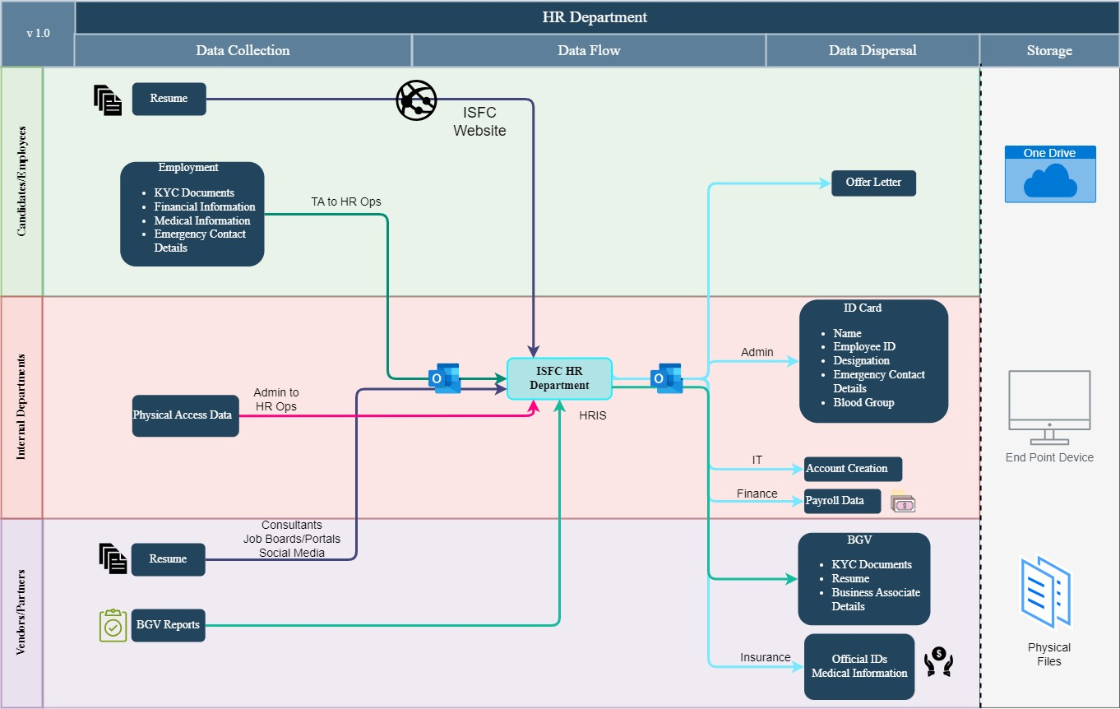
Data Flow Diagram (DFD)

Data Mapping and Inventory
S. No | Data Category | Description | Purpose | Data Owner | Storage Location | Data Classification* | Retention Period | Legal Basis
1. | Employee Personal Data | Personal information of employees including name, DOB, KYC Documents, etc. | HR management and payroll processing | HR Dept | HRIS | PII/Sensitive | As required by law | Legal obligation
2. | Job Applications | Applications for job positions submitted by candidates including Resumes | Recruitment and selection process | HR Dept | HRIS/ Emails/ One Drive | PII/Sensitive | Not Defined | Consent Required
3. | Performance Reviews | Records of employee performance evaluations | Performance assessment and improvement | HR Dept | HRIS/ Emails | Non - PII/  Private | Not Defined | NA
4. | Training Records | Information about employee training and development activities | Employee skill enhancement | HR Dept | Emails | Non - PII/  Private | Not Defined | NA
5. | Disciplinary Records | Documentation of employee disciplinary actions | Maintain discipline and compliance | HR Dept | HRIS | Non - PII/  Sensitive | Not Defined | NA
6. | Employee Emergency Contact Details | Contact information of employees’ family including phone and email | Communication and HR administration | HR Dept | HRIS/ Emails/ One Drive/ End Point Devices | PII/  Sensitive | Not Defined | Legitimate Interest
7. | Leave Records | Records of employee leave applications and approvals | Manage employee leave | HR Dept | Emails | Non -PII/  Private | Not Defined | NA
8. | Salary Information | Details of employee compensation and benefits | Payroll processing and administration | HR Dept | HRIS/One Drive/ End Point Devices | PII/  Sensitive | As required by law | Legal obligation
9. | Employee Surveys | Feedback and opinions provided by employees | Measure employee satisfaction | HR Dept | HRIS/ Emails | Non - PII/  Restricted | Not Defined | NA
10. | Employee & Family Personal Details and Health Records | Details of Employee Insurances, Parental Insurance (if opted by employee) | Employee/ Group Insurance | HR Dept | HRIS/ One Drive | PII/Sensitive | Not Defined | Legal Obligation
*Refer Appendix A

Recommendations
- Document Data Management Review:
- Conduct a comprehensive review of document management practices, including data classification, storage, sharing, and retention policies, to ensure alignment with data protection and privacy requirements.
- Establish clear guidelines for handling sensitive documents, including encryption protocols and access controls, to minimize the risk of unauthorized disclosure.

- Training & Awareness on Personally Identifiable Information (PII) data:
- Liaise with InfoSec team on creating Security awareness trainings for all employees on an annual basis.
- Include Privacy training in training calendar for all employees.

- Vendor Management
  - Include data protection obligations, including security measures, data handling practices, and retention periods in contracts with background verification vendors.
  - Regular review and assessment of the security measures and data handling practices of background verification vendors to ensure compliance with DPDPA requirements.

Action Plan

Requirements (ISFC to share the following)
- Checklist for Hiring Process

Conclusion
In conclusion, the assessment of key activities within the Human Resource Department of India Shelter Finance Corporation Limited (ISFC) reveals both strengths and areas for improvement. While structured recruitment processes demonstrate organizational diligence, there's a pressing need to formalize personal data management policies, particularly concerning retention and deletion practices. Recommendations emphasize the importance of comprehensive document management reviews and enhanced training programs to bolster data protection measures and foster a culture of privacy awareness. By addressing these recommendations, ISFC can fortify its information security posture, mitigate risks, and ensure compliance with regulatory requirements, thereby safeguarding sensitive employee data and upholding its commitment to data protection and privacy.

Appendices

Appendix A
Data Classification | Definition
Sensitive Data | Information that, if disclosed, altered, or destroyed without authorization, could cause significant harm to an individual, organization, or entity. This often includes financial records, medical information, and PII.
Restricted Data | Highly sensitive data tightly controlled due to legal, regulatory, or contractual requirements. Access is limited to authorized personnel, and any unauthorized disclosure may result in severe consequences.
Private Data | Information considered confidential and intended solely for specific individuals or groups within an organization. It requires protection from unauthorized access to maintain privacy and uphold confidentiality agreements.
Confidential Data | Privileged or proprietary information of an organization requiring protection from unauthorized access, disclosure, or alteration.
Public Data | Information that is freely available and accessible to the general public without restrictions or limitations. It does not contain sensitive or confidential information and can be openly accessed and used for various purposes such as research, analysis, and public interest initiatives.
PII (Personally Identifiable Information) | Data that can identify, contact, or locate an individual, either alone or in combination with other information. For example - names, addresses, official identifiers (Aadhar, Pan, DL, biometrics, etc).
Non-PII | Data that, while not personally identifiable, however may still require protection due to its sensitivity or confidentiality. This may include corporate financial information, proprietary research data, or internal communications.

---------------------End of Report for HR Ops, TA, Training & Development Department-----------------

